**Donation Funding**

**Group: 8**

Title: Registration

User Story Template

**Title:** **Registration**

**Priority: high**

**Estimate: It will take 2 hours for 2 members**

**As a** regular user

**I want to** access the system

**so that I can** get my service

**Acceptance criteria**

**Given** the personal information

**When** insert all the information properly

**Then** an varication email will be sent

Platform: mobile application

Language/framework: we will use swift to develop this platform

**Title: Donation**

User Story Template

**Title: Donation**

**Priority: High**

**Estimate: It will take 3 hours for 2 members**

**As a** regular user

**I want to** make an donation

**so that I can** do the donate

**Acceptance criteria**

**Given** the payment option will be provided

**When** the payment option selected

**Then** can donate if I want

**Title: Application**

User Story Template

**Title: Application**

**Priority: High**

**Estimate: It will take 3 hours for 2 members**

**As a** Applicant user

**I want to** make an application

**so that I can** do the donate or need donation

**Acceptance criteria**

**Given** the donation option will be provided

**When** *some reason which are acceptable*

**Then** all the information will verify

**Title: Transfer Money**

User Story Template

**Title: Transfer Money**

**Priority: High**

**Estimate:**

**1 Hour-2 Hours**

**As a** manager user

**I want to** transfer money from my collected fund

**so that I can** make donation to an applicant for their need

**Acceptance criteria**

**Given** the application information

**When** all the information given by applicant for wanting donation are validated

**Then** transaction took place

**Title: Update Fund Balance**

User Story Template

**Title: Update Fund Balance**

**Priority: High**

**Estimate:**

**3-4 Hours**

**As a** regular user

**I want to** update fund balance

**so that I can** know the current total amount of our fund after every transaction and can update it thoroughly

**Acceptance criteria**

**Given** transaction took place

**When** the transaction value will be added or deducted

**Then** balance will be updated

**UI/UX Design**

**Front Page**

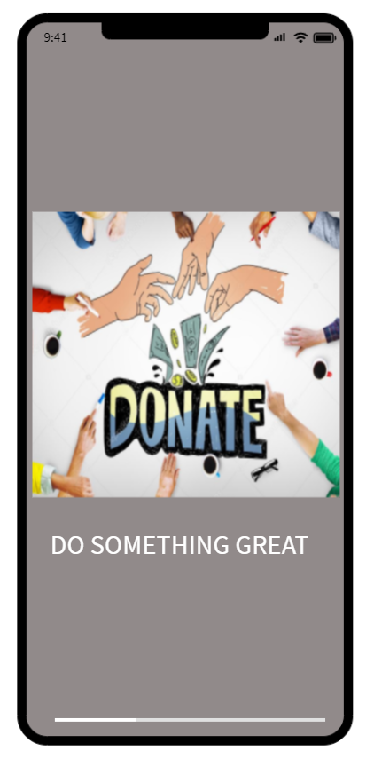

**Home Page**

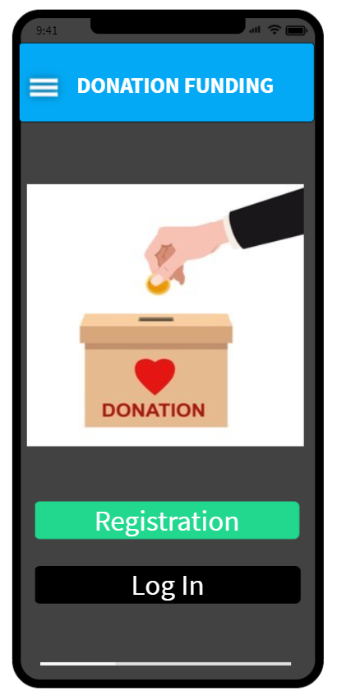

**Registration**

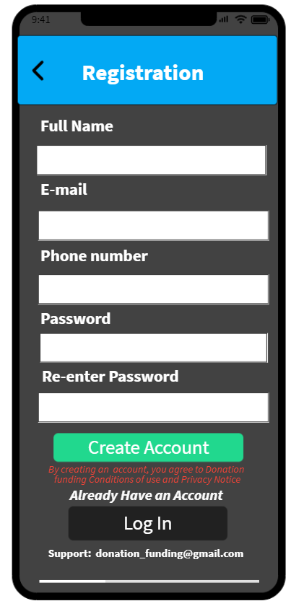

**Home page**

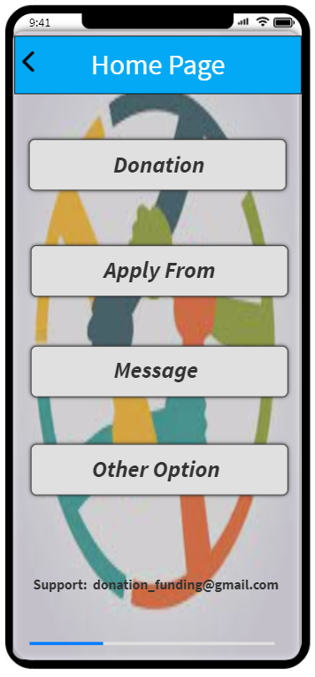

**Donation**

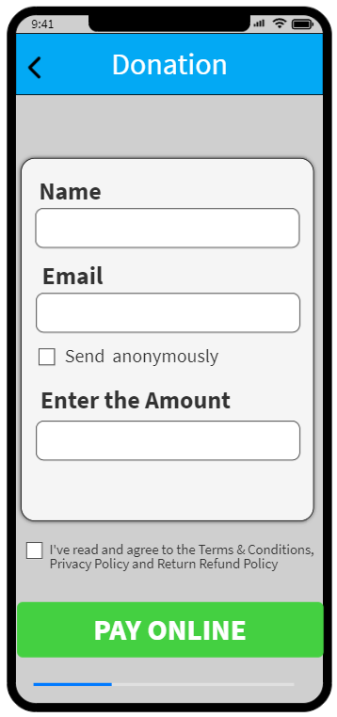

**Payment**

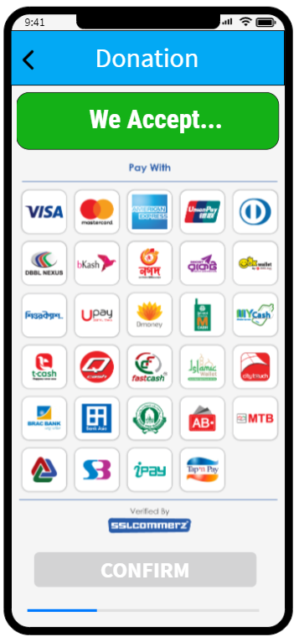

**Application from**

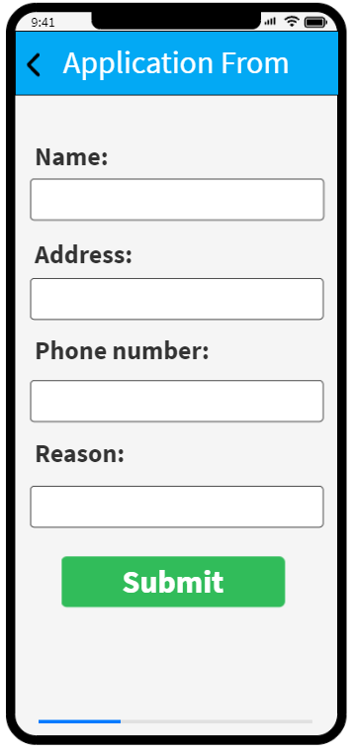

**Profile**

